Minnesota Touchstone Energy Cooperatives
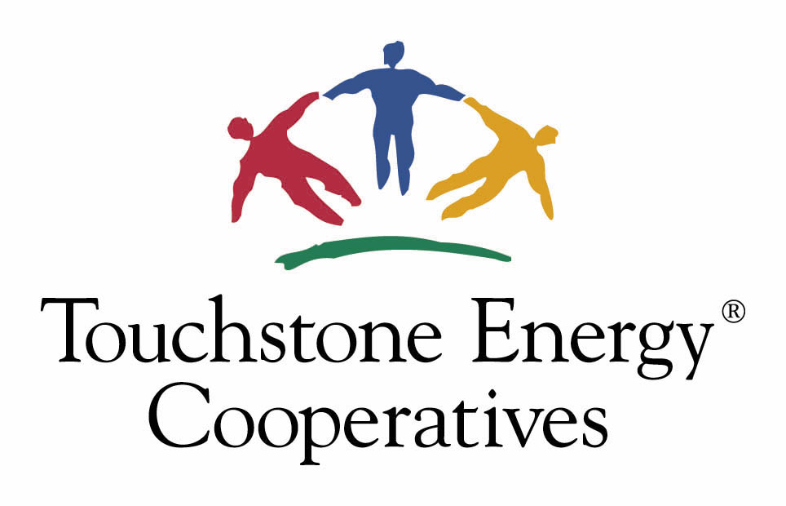

Community Award

Responses to the following questions will be used to judge the entries. Please respond with specific examples. You may attach additional pages, other documents and/or photographs as necessary. Return your application no later than 4:30 p.m. on November 1, 2024. Mail to: Lake Country Power, Attn: Tami Zaun, 26039 Bear Ridge Drive, Cohasset, MN 55721, or e-mail tzaun@lcp.coop. One winner will be selected to receive $500.

- Name and address of business or organization being nominated:

- Describe the project, event or organization:

- How has the project, event or organization impacted the community?

- About how many people have been touched in a positive way by this?

- What is the lasting impact?

Information about the person or organization making the nomination:

Contact Name: ________________________________________________________________________

Organization: _________________________________________________________________________

Address: _____________________________________________________________________________
____________________________________________________________________________________

Telephone: _____________________________Email:________________________________________

Touchstone Energy® Community Award

AWARD CRITERIA

This form doesn’t need to be filled out by the applicant, but can be used as a guide as the application is completed. Following is the criteria judges will use to evaluate the applications.

1. Objectives
What has been the focus of this organization's efforts?
(i.e. youth, community, economic development, environment, disaster relief)

2. Impact/Value
How has the organization helped to build a stronger community?
What specific goals have been achieved? How have programs/services been improved? What percentage of people within the co-op service territory was impacted?

3. Scope
Who has benefited from the efforts of this organization?
Consider how wide-ranging the efforts have been. How many people have been impacted? Has the organization collaborated with others? Is the project/organization multi-community?

4. Leadership
How has the organization demonstrated outstanding leadership?
Has the leadership inspired or trained others? What barriers or obstacles have been overcome to achieve goals? How have the people being served been involved in the programs or projects?

5. Use of Resources
How has the organization used resources wisely?
What means have been used to pull in resources? Have any money-saving innovations been implemented? Any resources leveraged due to a combined effort?

6. Length of Service
How long has this organization been a positive influence in the community?

7. Outreach/Communication
How have the organization’s efforts been communicated to the public?
What innovative ways have been used to publicize projects or programs to the audience? How has the organization been recognized by the community?

